UNITED STATES

SECURITIES AND EXCHANGE COMMISSION

Washington, D.C. 20549

FORM 8-K

CURRENT REPORT

PURSUANT TO SECTION 13 OR 15(d) OF THE

SECURITIES EXCHANGE ACT OF 1934

Date of Report (Date of earliest event reported): March 24, 2022

LORDSTOWN MOTORS CORP.

(Exact name of registrant as specified in its charter)

Delaware | 001-38821 | 83-2533239
(State or other jurisdiction | (Commission | (IRS Employer
of incorporation) | File Number) | Identification No.)
 | 2300 Hallock Young Road
 | Lordstown, Ohio 44481
 | (Address of principal executive offices, including zip code)
 | Registrant’s telephone number, including area code: (234) 285-4001

N/A

(Former name or former address, if changed since last report)

Check the appropriate box below if the Form 8-K filing is intended to simultaneously satisfy the filing obligation of the registrant under any of the following provisions:

- Written communications pursuant to Rule 425 under the Securities Act (17 CFR 230.425)

- Soliciting material pursuant to Rule 14a-12 under the Exchange Act (17 CFR 240.14a-12)

- Pre-commencement communications pursuant to Rule 14d-2(b) under the Exchange Act (17 CFR 240.14d-2(b))

- Pre-commencement communications pursuant to Rule 13e-4(c) under the Exchange Act (17 CFR 240.13e-4(c)) Securities registered pursuant to Section 12(b) of the Act:
Title of each class |  | Trading Symbol(s) |  | Name of each exchange on which registered
Class A common stock, par value $0.0001 per share |  | RIDE |  | The Nasdaq Stock Market LLC

Indicate by check mark whether the registrant is an emerging growth company as defined in Rule 405 of the Securities Act of 1933 (§230.405 of this chapter) or Rule 12b-2 of the Securities Exchange Act of 1934 (§240.12b-2 of this chapter).

Emerging growth company ☐

If an emerging growth company, indicate by check mark if the registrant has elected not to use the extended transition period for complying with any new or revised financial accounting standards provided pursuant to Section 13(a) of the Exchange Act. ☐

Item 7.01 Regulation FD

On March 24, 2022, Edward T. Hightower, President of Lordstown Motors Corp. (the “Company”) will deliver presentations as a keynote speaker at the MIH Partner Gathering 2022. During the presentations, Mr. Hightower will be providing certain information concerning the Company. Copies of the transcripts and slides from the presentations are attached as Exhibit 99.1, Exhibit 99.2, Exhibit 99.3 and Exhibit 99.4, respectively. To date, the Company has not reached an agreement with Foxconn EV Technology, Inc. or its affiliates to jointly develop vehicles off the MIH platform or with regard to any financing from Foxconn. No assurances can be given that any agreement will be reached or as to the terms of any such agreement. See “Forward-Looking Statements” below for risks and uncertainties that may affect the Company’s future results.

The information in this Current Report on Form 8-K is being furnished pursuant to Item 7.01 Regulation FD. In accordance with General Instruction B.2 of Form 8-K, the information in this report shall not be deemed “filed” for the purposes of Section 18 of the Securities Exchange Act of 1934, as amended (the “Exchange Act”), or otherwise subject to the liabilities of that section, nor shall it be deemed incorporated by reference in any filing under the Securities Act of 1933, as amended, or the Exchange Act, except as expressly stated by specific reference in such filing.

Forward-Looking Statements

This report includes forward looking statements. These statements are made under the “safe harbor” provisions of the U.S. Private Securities Litigation Reform Act of 1995. These statements may be identified by words such as “feel,” “expects,” “estimates,” “projects,” “intends,” “should,” “is to be,” or the negative of such terms, or other comparable terminology. Forward-looking statements are statements that are not historical facts. Such forward-looking statements are not guarantees of future performance and are subject to risks and uncertainties, which could cause actual results to differ materially from the forward-looking statements contained herein due to many factors, including, but not limited to: the need to raise substantial additional capital well in advance of our target of third quarter of 2022 for the start of commercial production and sale of our vehicles, to continue ongoing operations, and remain a going concern, and our ability to raise such funding on a reasonable timeline and with suitable terms; the cost and other impacts of litigation, regulatory proceedings, investigations, claims and/or adverse publicity, which may have a material adverse effect, whether or not successful or valid, on our business prospects and ability to obtain financing; our limited operating history and our ability to execute our business plan, including through any relationship with Foxconn; our ability to raise sufficient capital in the future in order to invest in the tooling to eventually lower the bill of materials cost for, and make continued design enhancements to, the Endurance and any future vehicles we may develop; the rollout of our business and the timing of expected business milestones, including our ability to complete the engineering of the Endurance, and conversion and retooling of the Lordstown facility, to establish and maintain appropriate supplier relationships, to successfully complete testing, homologation and certification, and to start production of the Endurance in accordance with our projected timeline; supply chain disruptions, inflation and the potential inability to source essential components and raw materials, including on a timely basis or at acceptable cost, and their consequences on testing, production, sales and other activities; our ability to obtain binding purchase orders and build customer relationships; our ability to deliver on the expectations of customers with respect to the pricing, performance, quality, reliability, safety and efficiency of the Endurance and to provide the levels of service and support that they will require; our ability to conduct business using a direct sales model, rather than through a dealer network used by most other OEMs; the effects of competition on our ability to market and sell vehicles; our inability to retain key personnel and to hire additional personnel; the ability to protect our intellectual property rights; the failure to obtain required regulatory approvals; changes in laws, regulatory requirements, governmental incentives and fuel and energy prices; the impact of health epidemics, including the COVID-19 pandemic, on our business; cybersecurity threats and compliance with privacy and data protection laws; failure to timely implement and maintain adequate financial, information technology and management processes and controls and procedures; and the possibility that we may be adversely affected by other economic, geopolitical, business and/or competitive factors.

In addition, the transactions contemplated with Foxconn under the asset purchase agreement with Foxconn EV Technology, Inc., an Ohio corporation (“Foxconn Ohio”) and an affiliate of Hon Hai Technology Group (“Foxconn”), dated November 10, 2021 (the “Asset Purchase Agreement”), are subject to closing conditions, including further negotiation and execution of the contract manufacturing agreement and regulatory approvals, and may not be consummated. While negotiations continue, no assurances can be given that Lordstown Motors and Foxconn will enter into the agreements contemplated by the Asset Purchase Agreement or a joint product development or similar agreement to co-design and develop vehicle programs and an appropriate funding structure, or as to the terms of any such agreement. If we are unable to successfully complete the contemplated transactions and relationship with Foxconn on a timely basis, our business plan, financial condition and results of operations would be materially and adversely impaired. We need substantial additional funding to begin production of the Endurance in the third quarter of 2022. Further information on potential factors that could affect the financial results of the Company and its forward-looking statements is included in its most recent Form 10-K and subsequent filings with the Securities and Exchange Commission. All forward-looking statements are qualified in their entirety by this cautionary statement. Any forward-looking statements speak only as of the date on which they are made, and Lordstown Motors undertakes no obligation to update any forward-looking statement to reflect events or circumstances after the date of this report.

Item 9.01 |  |  | Financial Statements and Exhibits.
(d) Exhibits.
Exhibit
Number |  |  | Description
99.1 |  |  | Transcript of business briefing presentation, dated March 24, 2022
99.2 |  |  | Transcript of keynote presentation, dated March 24, 2022
99.3 |  |  | Business briefing presentation, dated March 24, 2022
99.4 |  |  | Keynote presentation, dated March 24, 2022
104 |  |  | Cover Page Interactive Data File (formatted as inline XBRL)

SIGNATURES

Pursuant to the requirements of the Securities Exchange Act of 1934, the registrant has duly caused this report to be signed on its behalf by the undersigned hereunto duly authorized.

LORDSTOWN MOTORS CORP.

By: | /s/ Adam Kroll
Name: | Adam Kroll
Title: | Chief Financial Officer

Date: March 24, 2022

Exhibit 99.1

Edward Hightower

Hello, everyone. My name is Edward Hightower, and I'm the president of Lordstown Motors. Lordstown Motors is an electric vehicle manufacturer focused on the Commercial Fleet segment. Everything we do is with workers in mind.

Our mission is to drive EV adoption through products, production and partnerships.

Today, I want to talk to you a little bit about who Lordstown Motors is. Our first product, the Endurance, a full-size pick up. The capabilities of our organization, along with what we see as trends in the commercial fleet market. So a little bit about us, Lordstown Motors. We've transformed our team and our culture to bring the Endurance, our first product, to market in the third quarter of 2022. That's part of our mission to accelerate the transition towards electric vehicles. Since 2021, Lordstown Motors has taken transformative steps to build the team, the strategy, the culture and our capabilities to succeed in the commercial fleet battery electric vehicle market. We're very excited about our planned partnership with Foxconn because it will support the EV ambitions of both companies. It will create synergies in vehicle development sourcing and manufacturing. From a manufacturing standpoint, Foxconn's acquisition of the Lordstown, Ohio plant will give the company an EV contract manufacturing footprint in North America. In addition, it will allow Lordstown Motors to evolve from a high-asset OEM to an asset-light manufacturer focused on technology, innovation and product development. Speaking of product development, our planned partnership with Foxconn will enable us to develop new products off of the MIH “Mobility in Harmony” platform.

This platform, sharing it with our partners and other OEMs, will allow smaller OEMs like us to gain scale through the shared components, shared vehicle architecture and shared engineering. Speaking of sharing, partnering with Foxconn and their global network of suppliers, being one of the world's largest contract manufacturers of consumer electronics, we expect will give us benefits from lower bill of material costs and allow us to access new technologies that will be crucial to the connectivity features that our fleet and commercial customers will demand.

Our new senior leadership team at Lordstown Motors is in place, and we are building a company culture around three principles integrity, operating with transparency, and doing what we say; discipline, putting in the systems, processes and metrics to drive our business and meet our objective; and finally, collaboration, building great partnerships in order to succeed. Our mission is to accelerate EV adoption, and we have a clear strategy and clear focus on that mission.

Our immediate focus is to launch the Endurance pickup truck in the third quarter of 2022, we're an engineering technology company focused on the fundamentals of what it takes to build an all-electric truck specifically for work. Speaking of that truck, let's talk a little bit about our product, the Endurance, our full-size pickup truck, and our first product is a fleet first product with high durability, maneuverability, connectivity and a bespoke design for fleets to get the work done.

Speaking of durability, as a battery electric vehicle, we expect to have higher durability and a lower total cost of ownership. Our four in-wheel hub motors and our lower center of gravity will give us superior handling and superior maneuverability as well as a tighter turning radius. The design of our truck is bespoke and focused on customers that use their truck for work.

And finally, finally, we'll have fleet management systems, over-the-air update and connectivity features that will be demanded by our commercial fleet customers. The four in-wheel hub motors, in addition to generating 550 horsepower along with our lower center of gravity, will provide a unique point of differentiation versus other electric vehicle pickups on the market. And that will enter the market in the future. In the future, it will deliver superior handling, traction control, torque, and as I mentioned, a tighter turning radius. The design of the Endurance is a tailor-made tool for work. Our towing capacity is 8,000 pounds and we have a payload of 1200 pounds. In addition, we have 9.6 cubic feet of additional lockable storage in our front trunk or frunk to allow our work customers, our commercial fleet customers to put their tools or other products that they want to lock away and keep out of sight.

That lockable Frunk also has a 400 watt auxiliary power outlet. So we've talked about the hardware. Let's talk a little bit about the software. The Endurance will offer advanced fleet management solutions, cyber security features and connected vehicle features from a fleet management solutions perspective. Our Integrated Software, Telematics and Fleet Management Solutions will provide expansive vehicle operating data catalog to our customers. Cyber security will include controller zone, domain zone and vehicle zone protection, and our connectivity features will include important features such as GEOFENCE Alerts, State of charge info, event notifications, customized diagnostics, remote preconditioning of the battery, as well as video streaming. Let's talk a bit about the capabilities of the Lordstown organization, our proposed Joint Product Development Agreement, or JPDA with Foxconn, will bolster our ability to meet the BEV needs of our commercial fleet customers.

Lordstown, together with Foxconn, we through our proposed joint product development agreement, will have the capabilities to deliver EV programs for multiple OEMs from concept through launch from strategy, including planning and program management through design, engineering, sourcing and manufacturing and supporting all of those elements of the vehicle development process. Our organization focused on total enterprise, quality, finance and information technology. Our cross-functional organization can engineer and deliver both electric vehicle programs for multiple OEMs along with vehicle subsystems and components.

From a vehicle subsystems standpoint, we have capabilities in the areas of propulsion, chassis, thermal interior, exterior body safety, as well as information, infotainment and cybersecurity. Each of our vehicle programs will be supported by our cross-functional resources outside of engineering, including purchasing, design, finance, quality, marketing, and the voice of the customer. Our proposed joint product development agreement with Foxconn will allow us to share these resources and our expertise with other Foxconn resources in other parts of the world.

In addition, Lordstown, we aspire and seek to engineer and develop vehicle components and subsystems for the MIH platform for use by other OEMs. One example of that is the electric vehicle architecture. Lordstown, we have the capabilities to develop the electric architecture for OEM users of the MIH platform. Our proposed electrical architecture could be zonal with the domain controller through the vehicle platform system and include the integration of sensors and actuators.

Let's talk a little bit about the market trends. We anticipate opportunity for our commercial fleet customers in developing software defined vehicles, along with opportunities for suppliers to localize near the Lordstown plant. As we discussed in the earlier session. Lordstown expects continued growth in the battery electric vehicle, commercial fleet pickup and van segments, creating opportunities for MIH and the Endurance platforms.

Along with the vehicles, we see growth and connectivity demands from our customers and creating additional opportunities for software defined vehicles. In addition to the ADAS and over the air update features which we plan to offer the Endurance, we plan to be part of the migration of the industry towards software defined vehicles using 5G connectivity and the sharing of data between the vehicle and the off vehicle infrastructure.

This will enable us to deliver more features, more connectivity and important functionality through the software system that is desired and needed by our customers for their work and for their businesses. In addition to the software defined vehicle, we see additional opportunities in ADAS and Autonomy features. Now, level one in level to ADAS as defined by SAE is expected in the Light Commercial Vehicle segment. However, we see opportunities for MIH suppliers, for light commercial vehicles to extend those offerings into level three and level four as level three and level four, autonomy is expected to grow 17% and 50% respectively. Led by offerings from Tesla, Renault, Nissan, Mitsubishi and GM. Finally, both Foxconn and Lordstown Motors, we support supply chain localization in Ohio and in the region.

In addition to job creation, localization can create cost reduction opportunities due to lower logistics costs lower tariff costs and reduced supply chain risks. So we see opportunities for vehicle component and subsystem suppliers in all major vehicles subsystems areas, including propulsion, battery and motors, chassis, thermal, interior, safety, exterior body, electrical and electronics and infotainment. So thank you again for your attention and I look forward to hearing your questions.

Exhibit 99.2

Edward Hightower

Well. Hello, everyone. My name is Edward Hightower, and I'm the president of Lordstown Motors. Lordstown Motors is an electric vehicle company that's focused on commercial solutions. Everything we do is with workers in mind. Our goal is to accelerate EV adoption through our products, production and partnerships. A little bit more about us. We've transformed our team and culture to focus on bringing our Endurance full size pickup to market. Since 2021, Lordstown has taken this transformative steps to build the team, the culture and the capabilities to succeed in the commercial fleet battery electric vehicle market. Our new senior leadership team is in place our principles endure. We are building a culture around three principles integrity, discipline and collaboration. These will govern the work that we do and help us bring our products to market for and serve our customers very well. We're executing our mission with a clear strategy and focus. Our mission is to accelerate EV adoption. So our strategy is to offer fleet-focused-first products. If you're going to have an impact on EV adoption, you want to build and offer the vehicles that are driven the most. That's why we're focusing on the commercial fleet market. Our number one priority this year is to launch our Endurance full size pickup in the third quarter of 2022.

Let's talk a little bit about market opportunities. We're anticipate market opportunities further than the Endurance within our commercial fleet market, especially where state, local and federal governments offer tax credits for replacing internal combustion engine vehicles with battery electric vehicles. Specifically in North America, our commercial fleet customers will primarily come from two segments, full size pickups, which sold three and a half million units in 2019, the last full year before COVID and the chip shortage, and similarly in vans which sold another 470,000 units in 2019. But what is also exciting to us at Lordstown Motors is the transition towards electrification so driven by the lower total cost of ownership that BEVs enable along with corporate ESG goals that many of our commercial fleet customers have.

BEV sales in these segments are forecast to grow significantly. 37% CAGR compound annual growth rate over the next ten years and the full size pickup truck market where our Endurance will be offered and will compete and similarly in vans a 22% CAGR over the next ten years between now and 2033. However along with the vehicles we're also excited about the growth in connectivity and the demands that our fleet commercial customers will have for these software enabled and software defined features.

So in addition to the features that we're going to offer and plan to offer in the Endurance whether they be ADAS over the air updates or our dynamic human machine interface for different functions and our screens, we are moving towards vehicle 4.0 where we will offer 5G connectivity edge applications and homogeneous computing platforms between the vehicle and the cloud.

We're very excited that this will be part of the future for the automotive industry and we're very excited to play a role in that. We are especially excited about our partnership between Lordstown and Foxconn because this will support the EV ambitions of both companies, creating synergies in vehicle development, sourcing and manufacturing from a manufacture standpoint. Foxconn's acquisition of the Lordstown, Ohio, plant will give the company an EV contract manufacturing footprint in North America. This agreement allows Lordstown Motors with the opportunity to evolve from an OEM with high fixed assets and being an asset light company that's focused on engineering, product development, innovation and serving our commercial fleet customers. From a vehicle development standpoint, Foxconn's Mobility-In-Harmony platform shared between multiple OEMs will reduce development costs, lead time and resource requirements This open hardware and software platform aspires to be the Android of battery electric vehicles, and we're excited for our plan to work with Foxconn in developing vehicles off of the MIH platform.

From a global sourcing standpoint, with Foxconn being the largest contract manufacturer of consumer electronics in the world with partners such as Apple, Sony, Google and Microsoft, we see additional opportunities for scale through Foxconn's sourcing and buying power. We see that as an opportunity to lower the bill of material cost of our products, both the current Endurance and our future MIH products.

And that will allow us to deliver higher levels of value to our customers, of which is a very high priority in the Commercial Fleet segment. So looking forward, these economies of scale presented by the platform will allow Lordstown to focus on the consumer facing design attributes that are important to our customers and then leverage the benefits of this common and flexible vehicle architecture.

Thank you for this discussion and I look forward to continuing the conversation in the partnership section of the summit

Exhibit 99.3
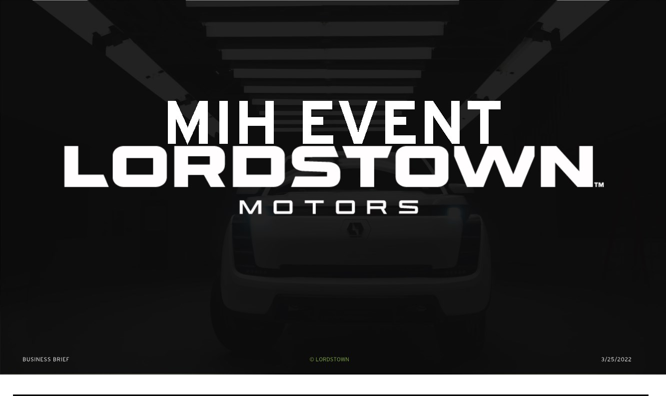

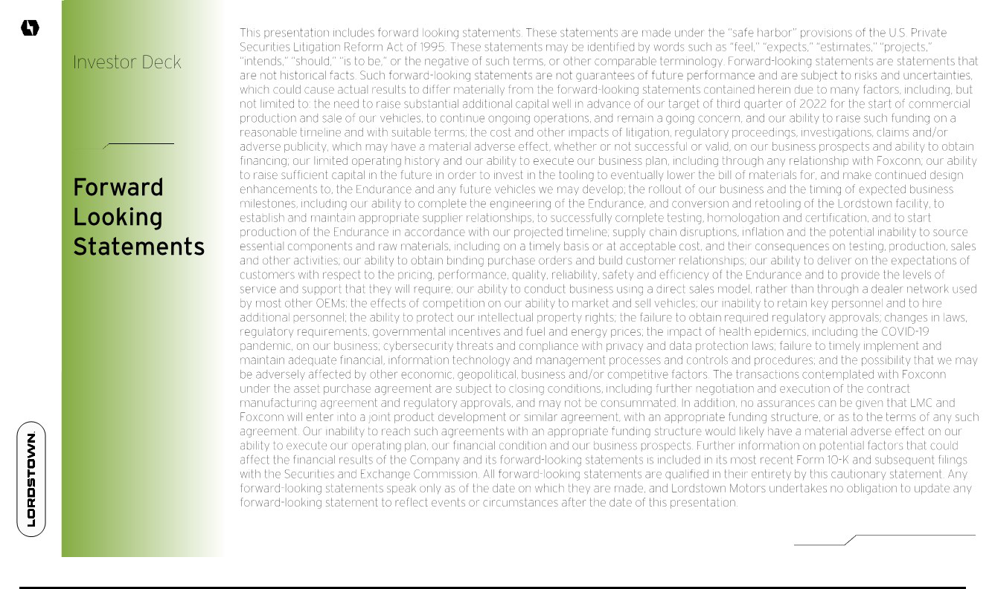

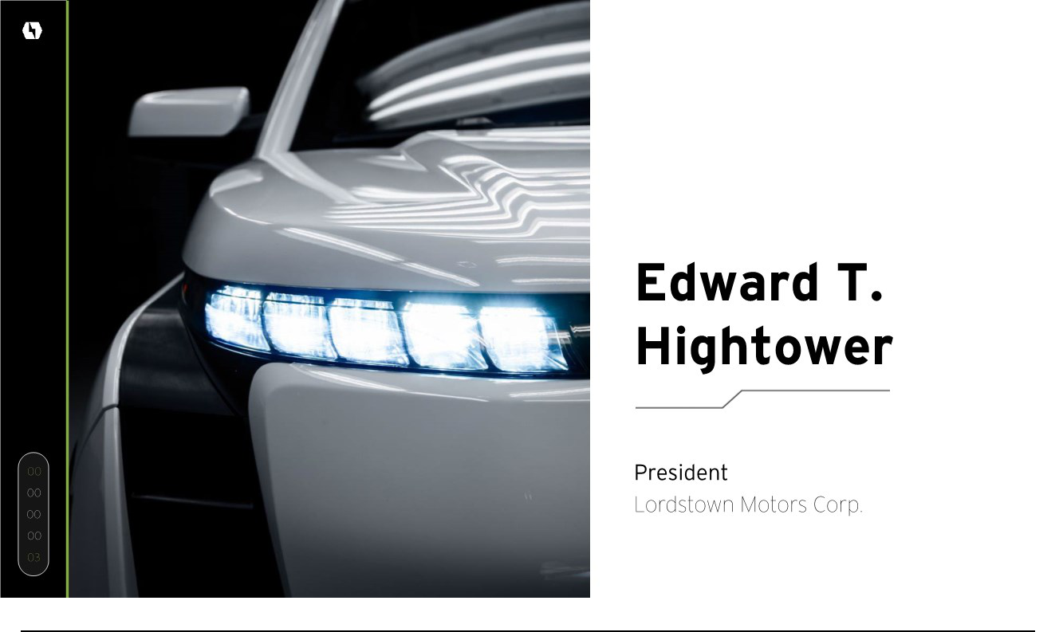

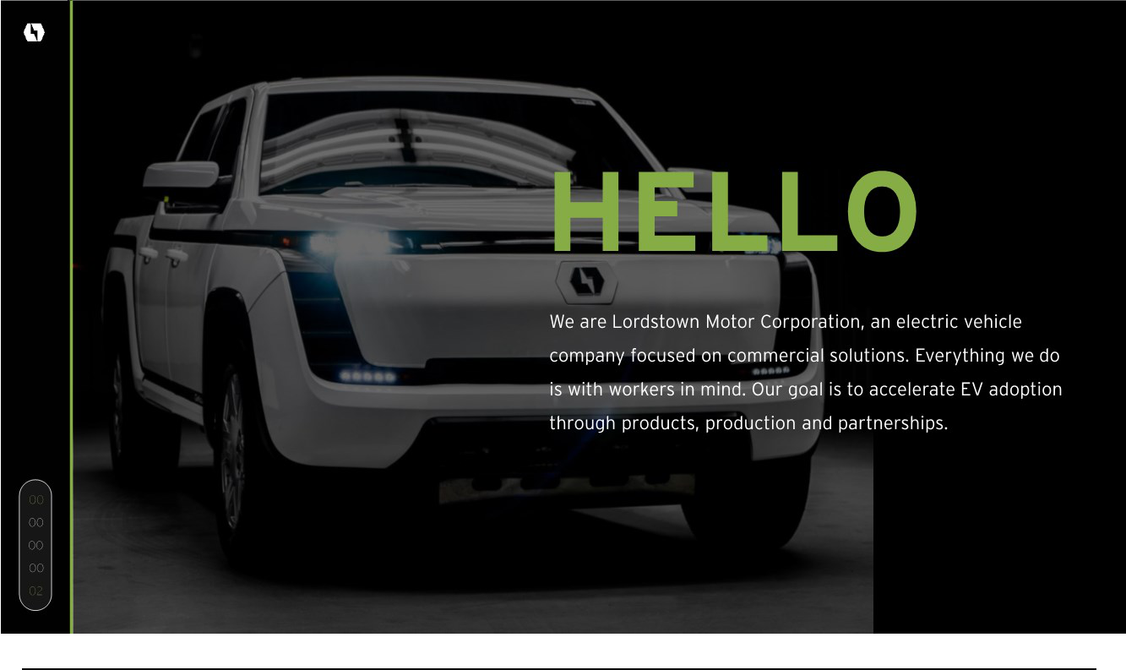

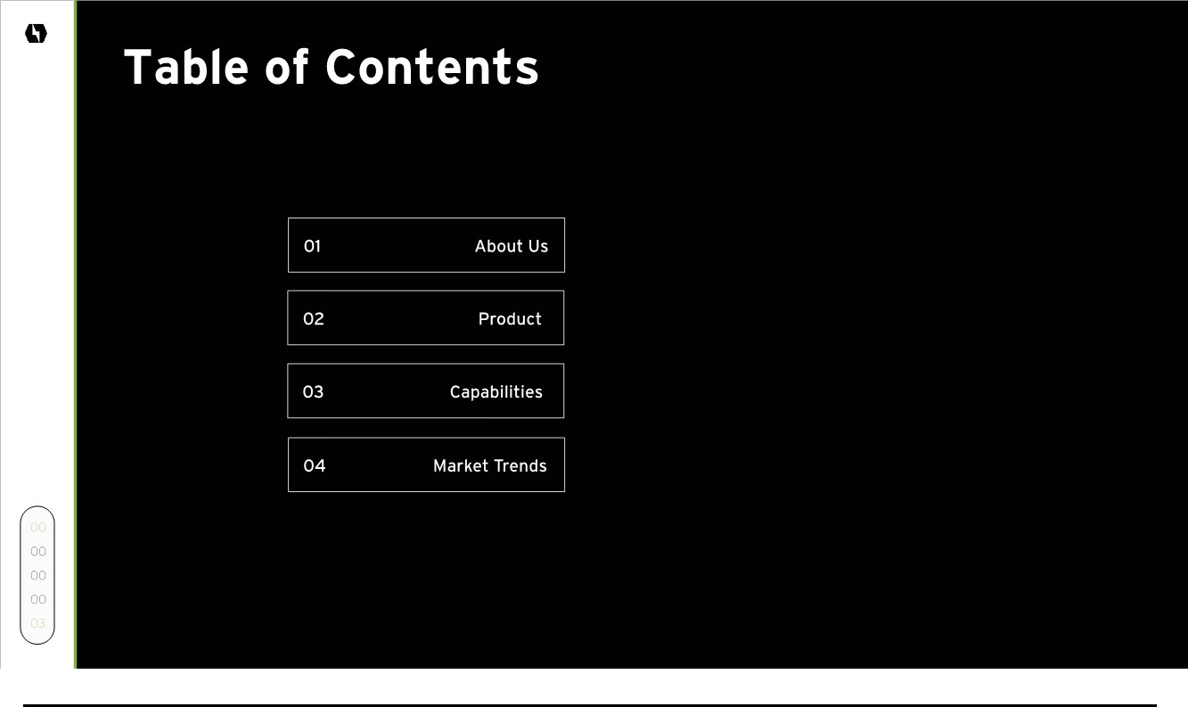

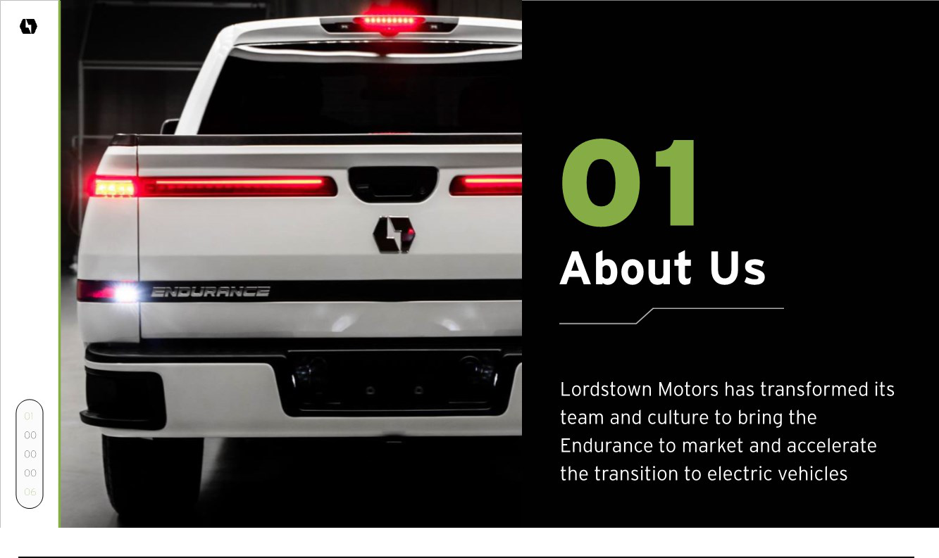

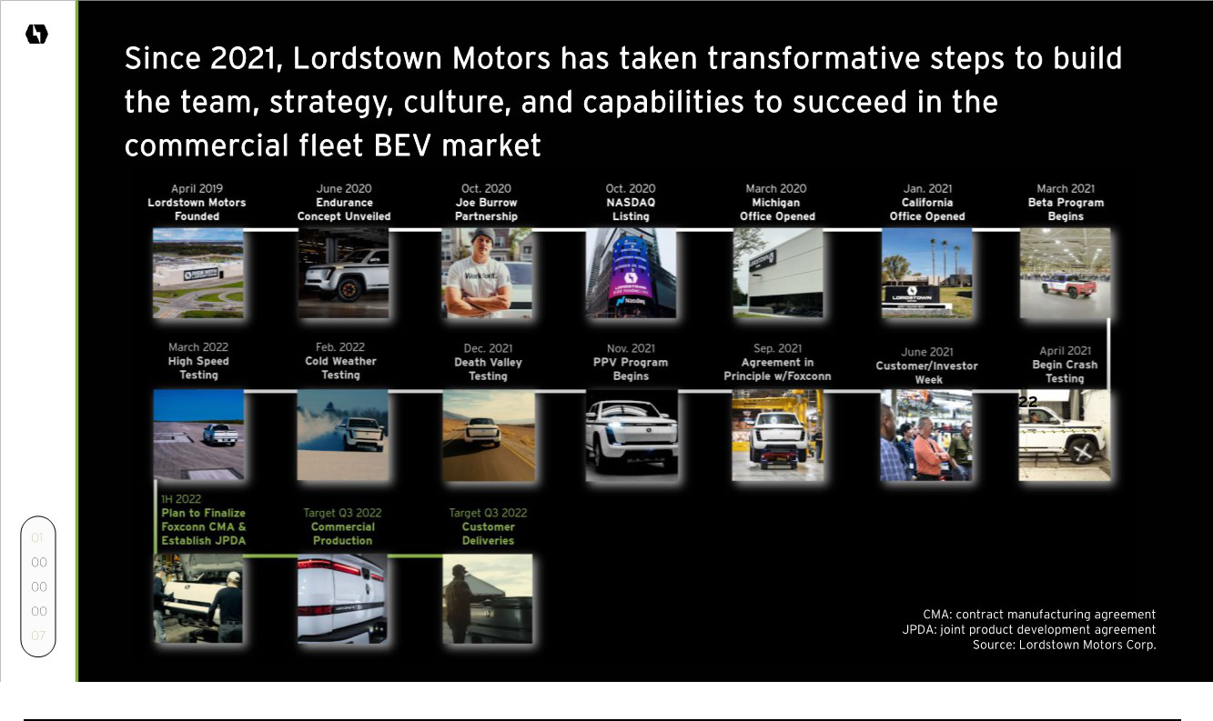

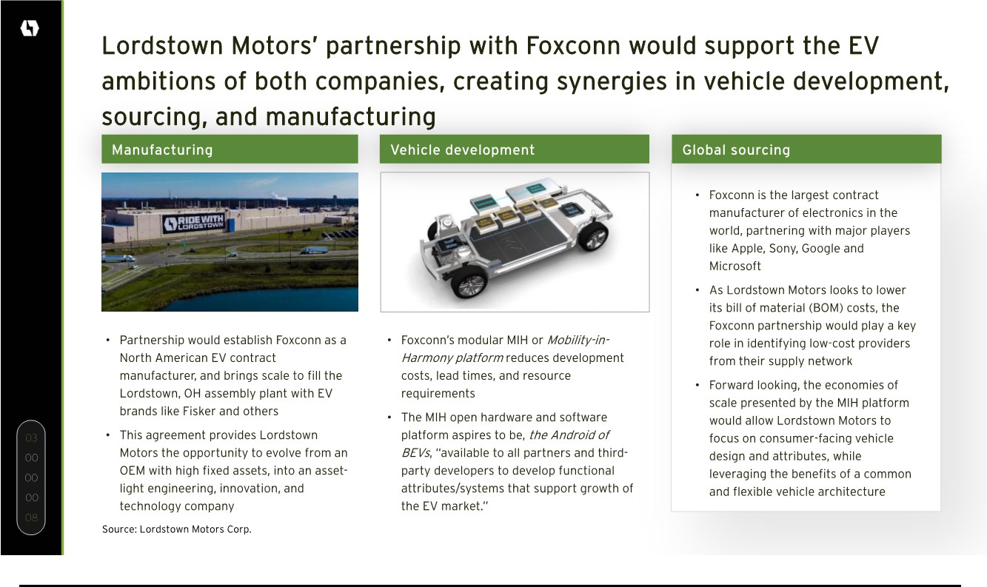

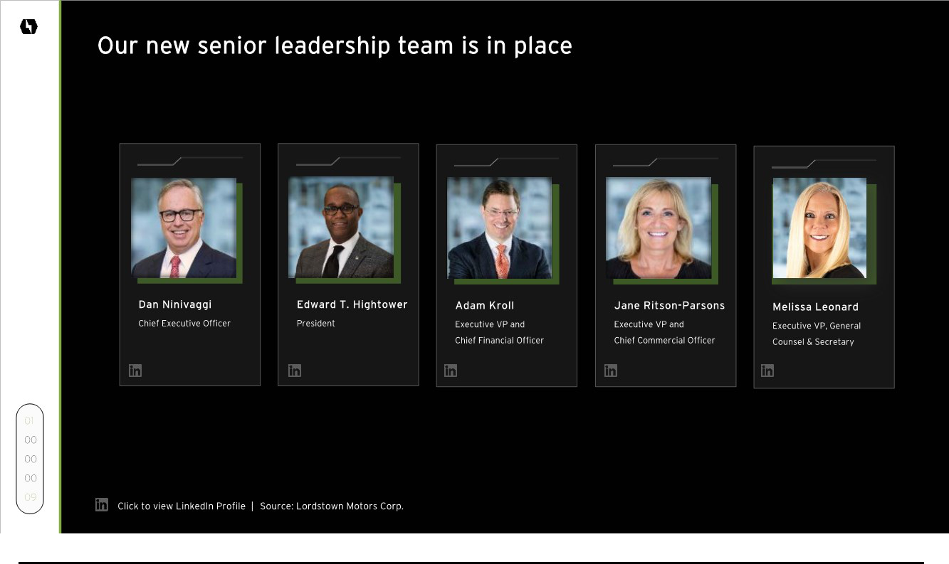

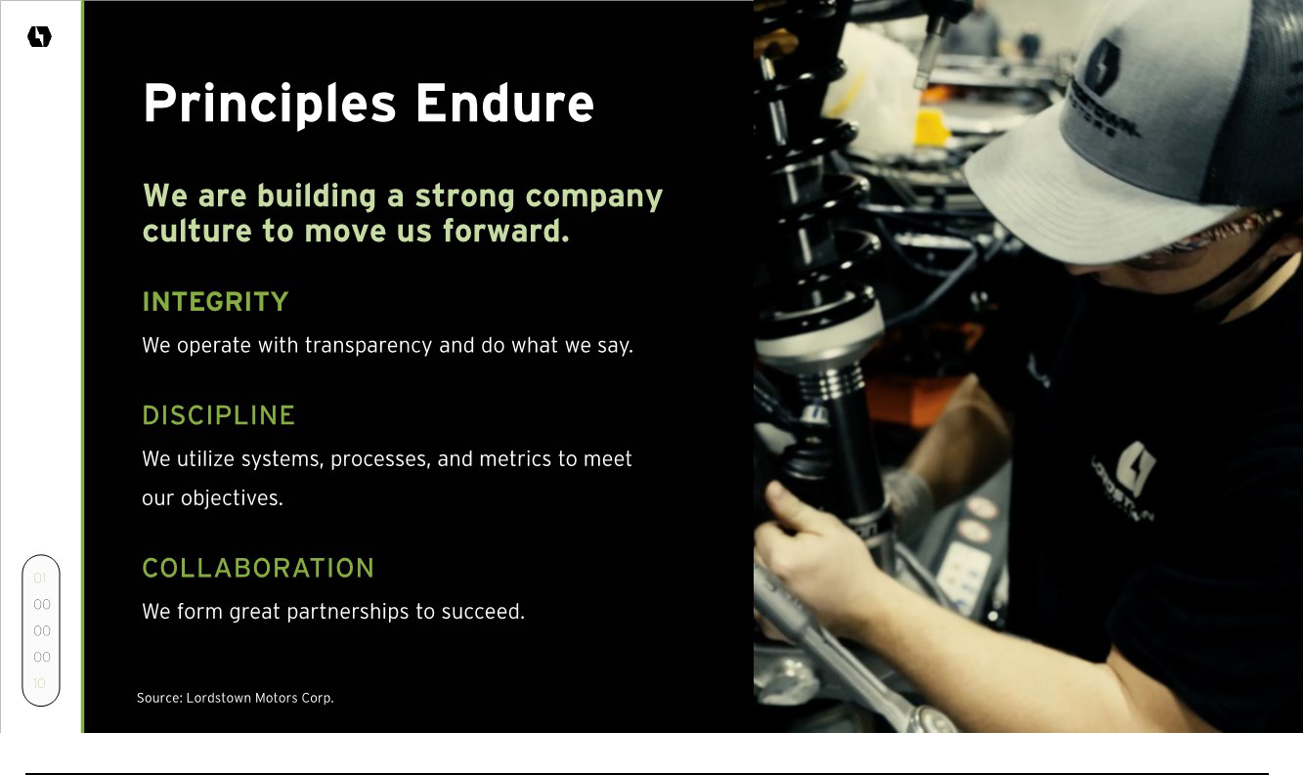

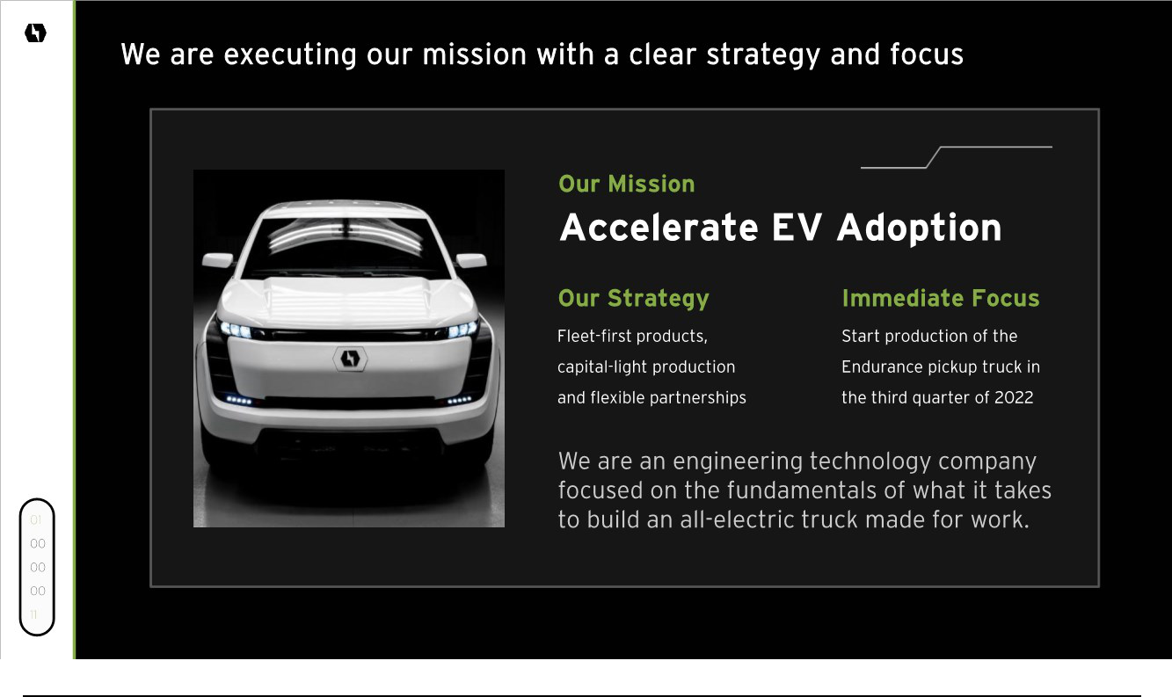

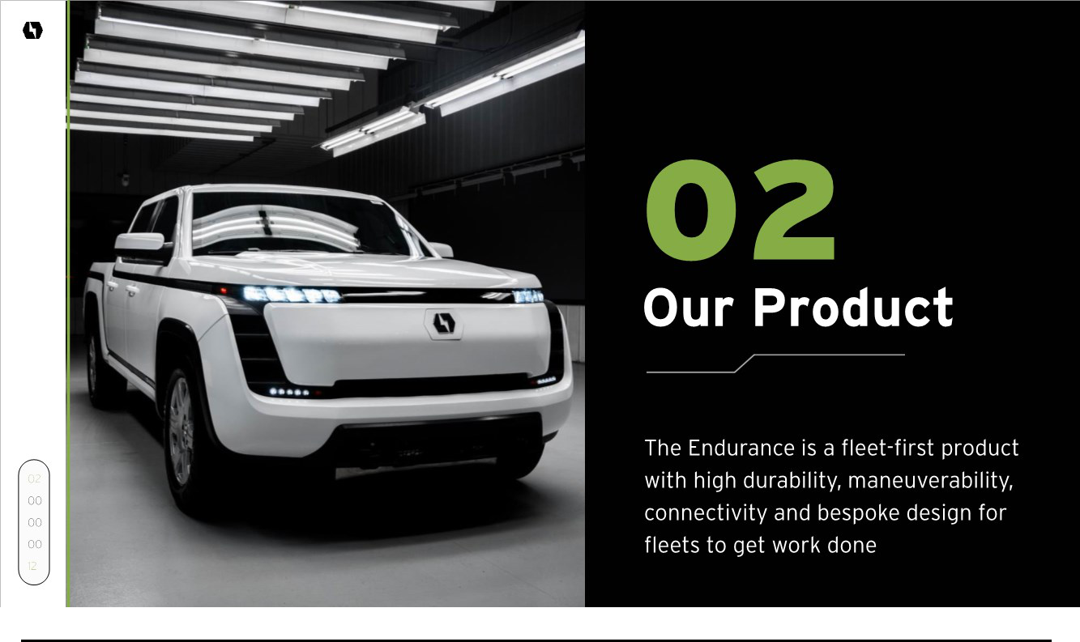

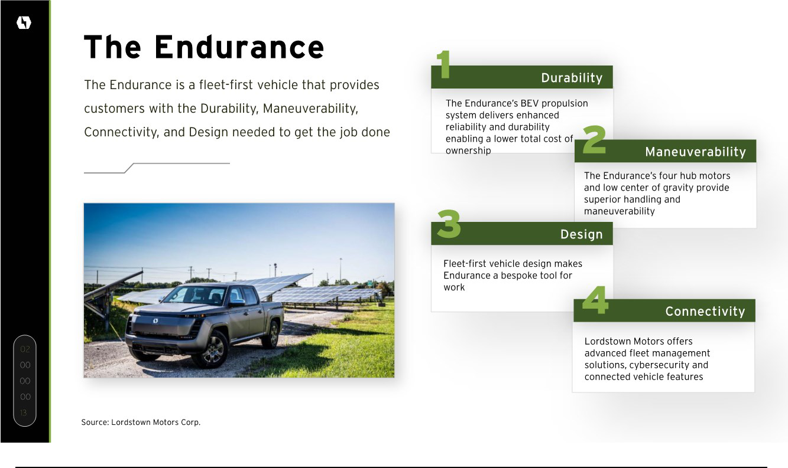

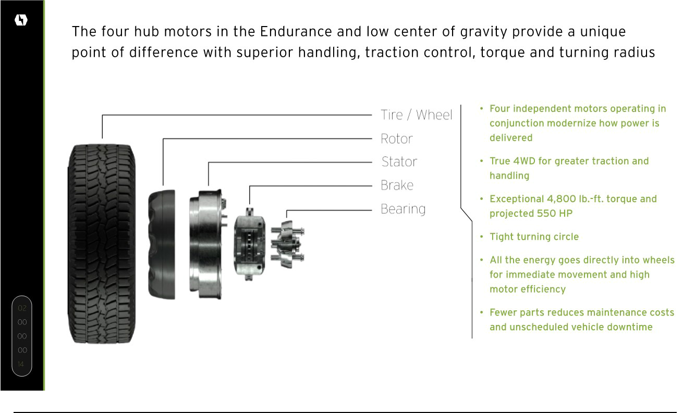

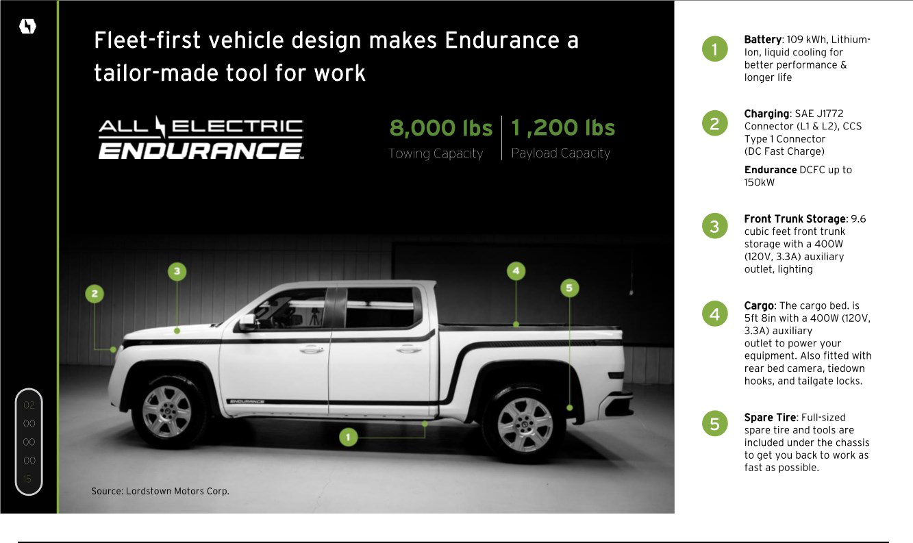

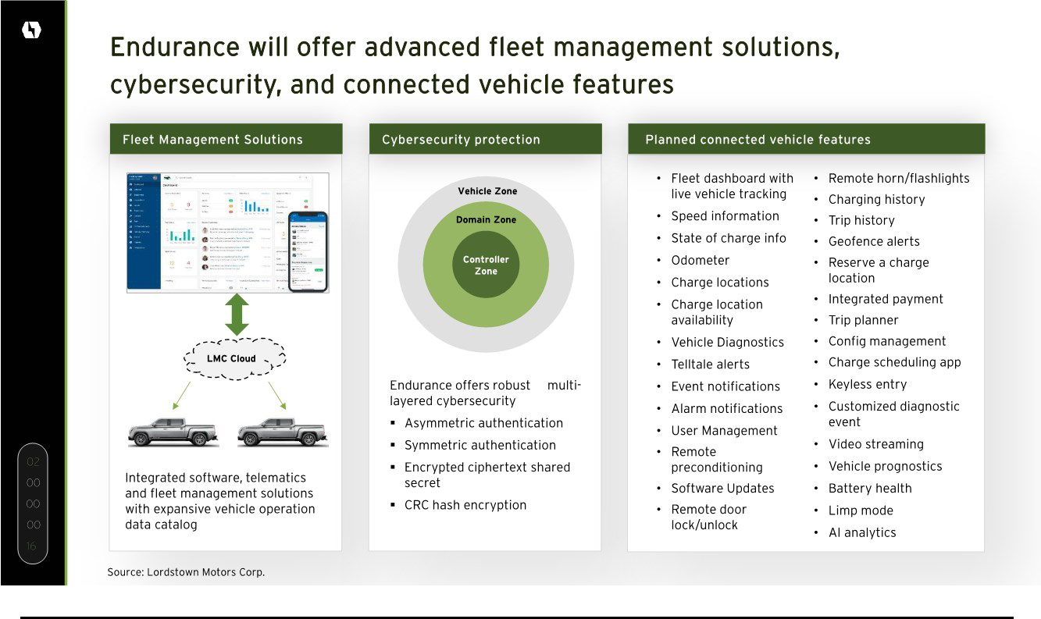

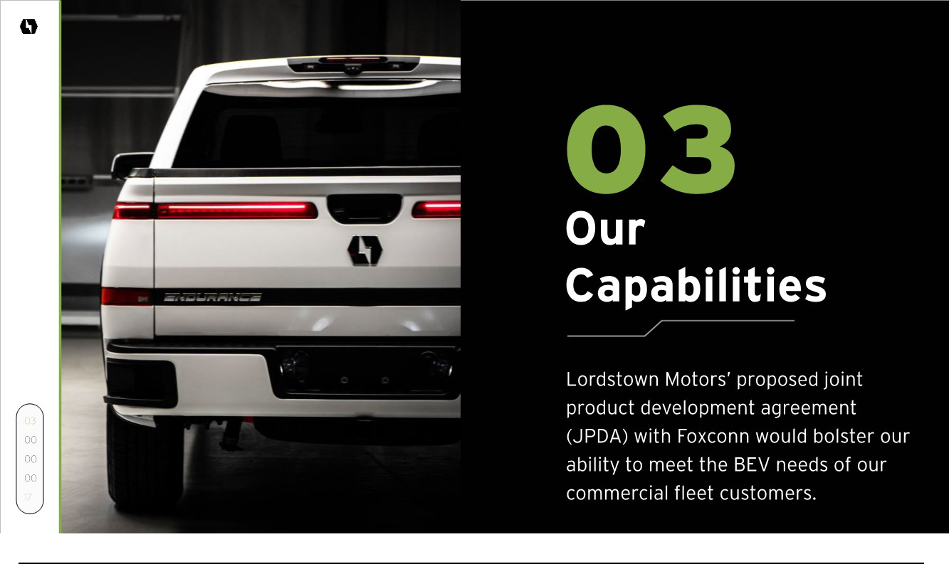

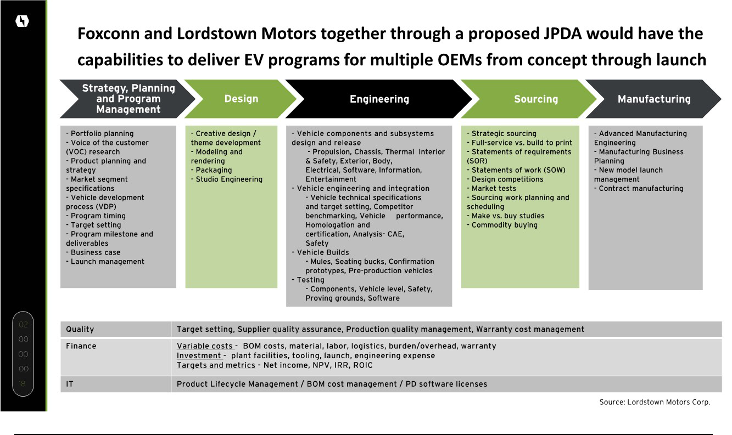

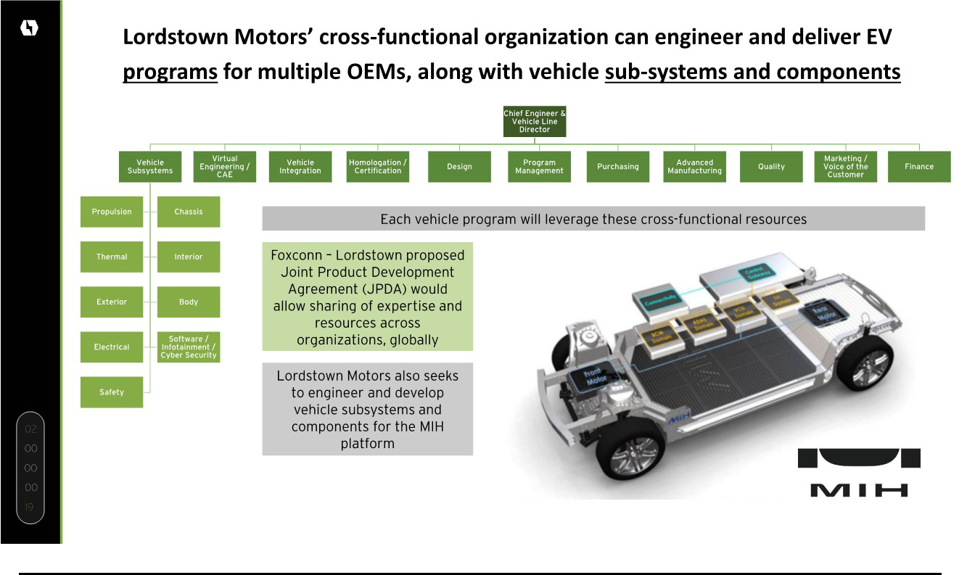

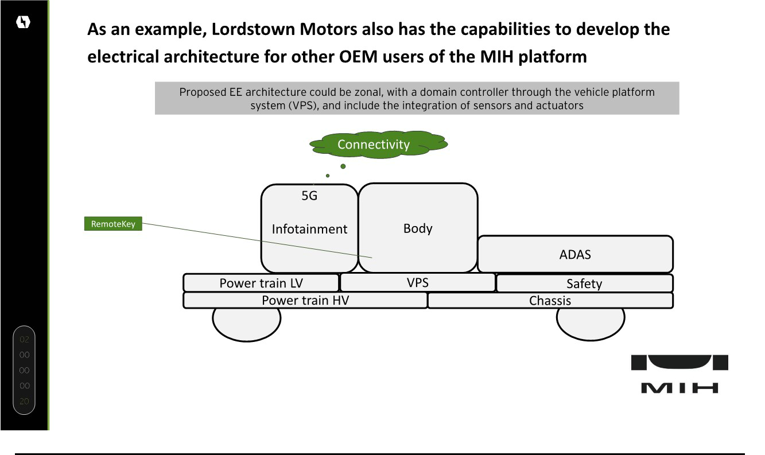

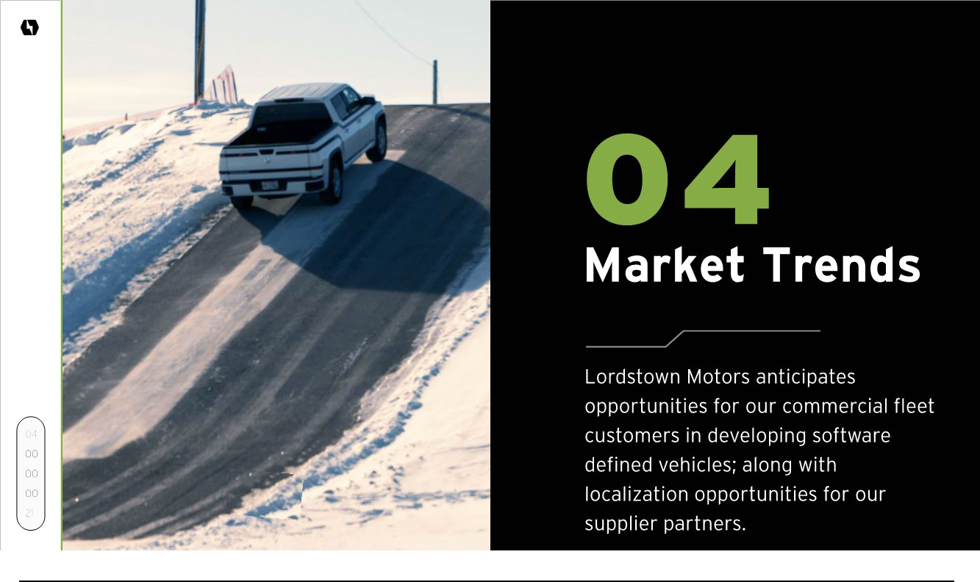

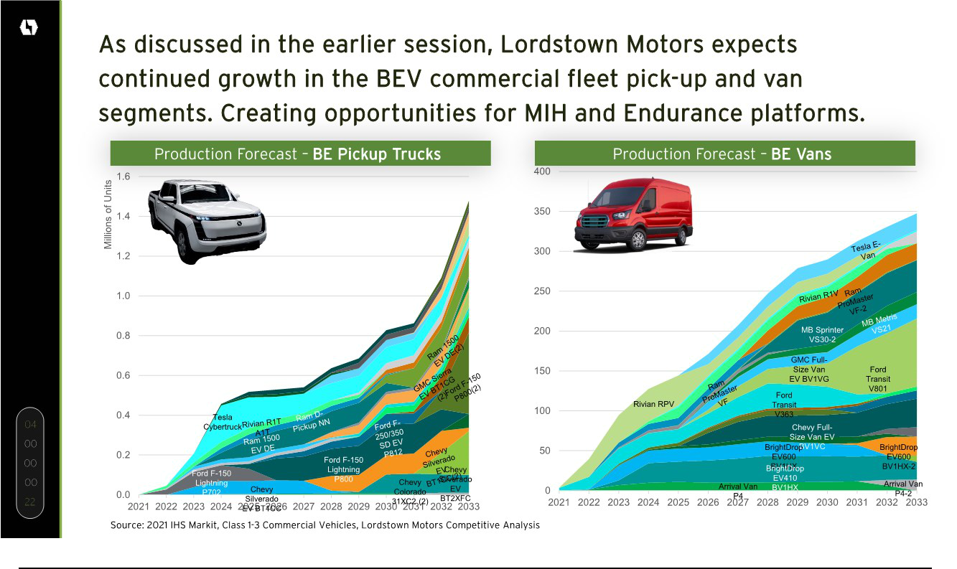

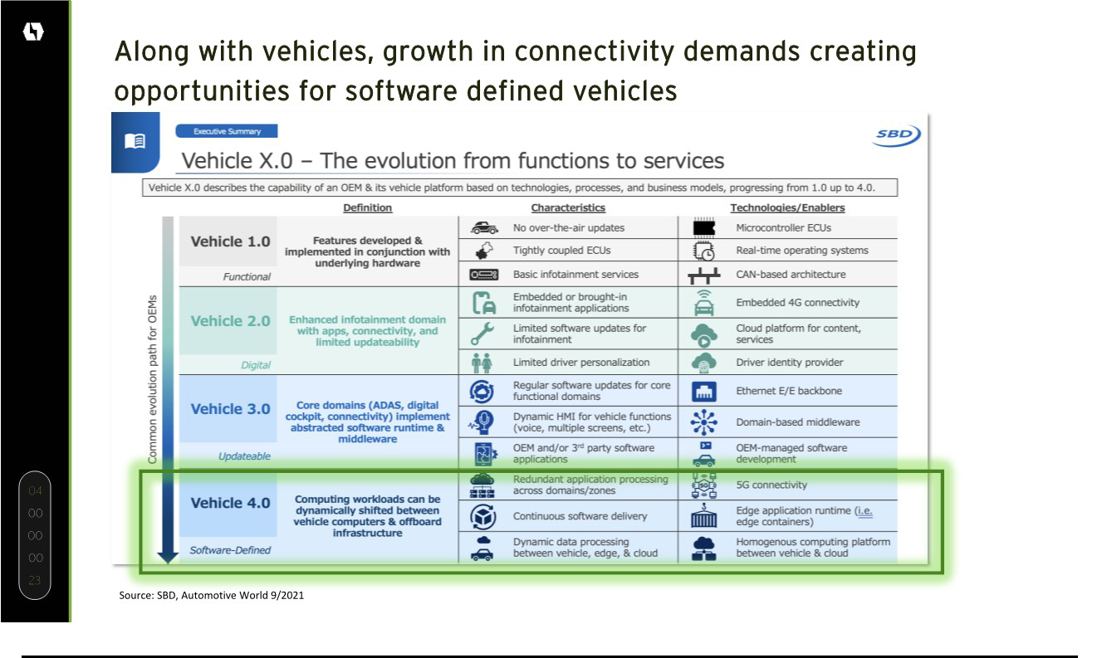

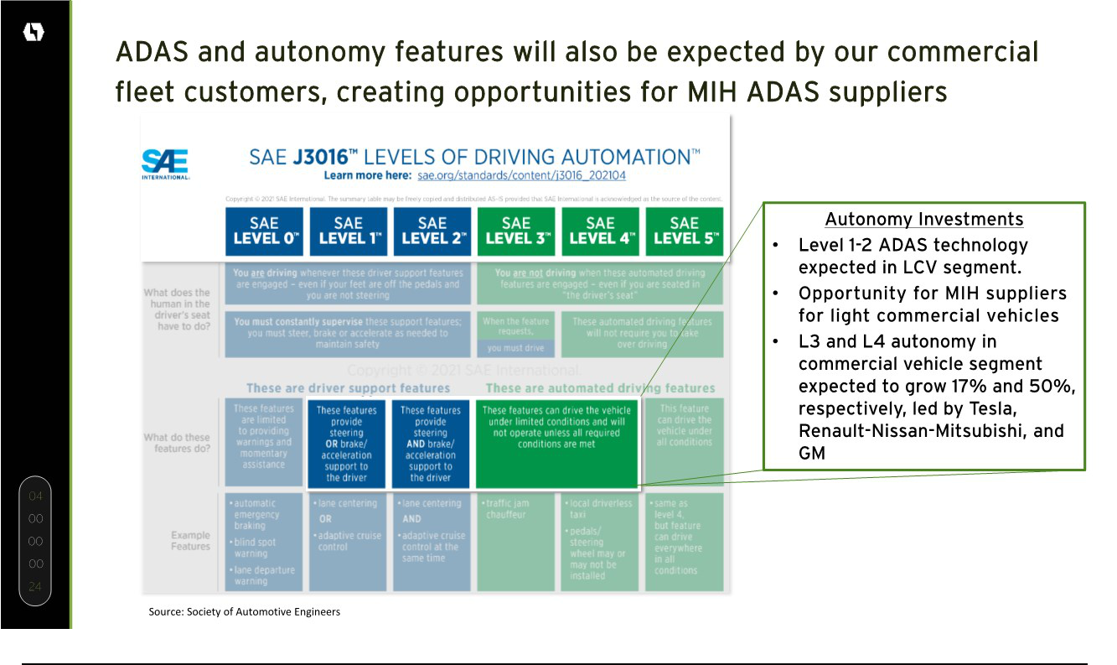

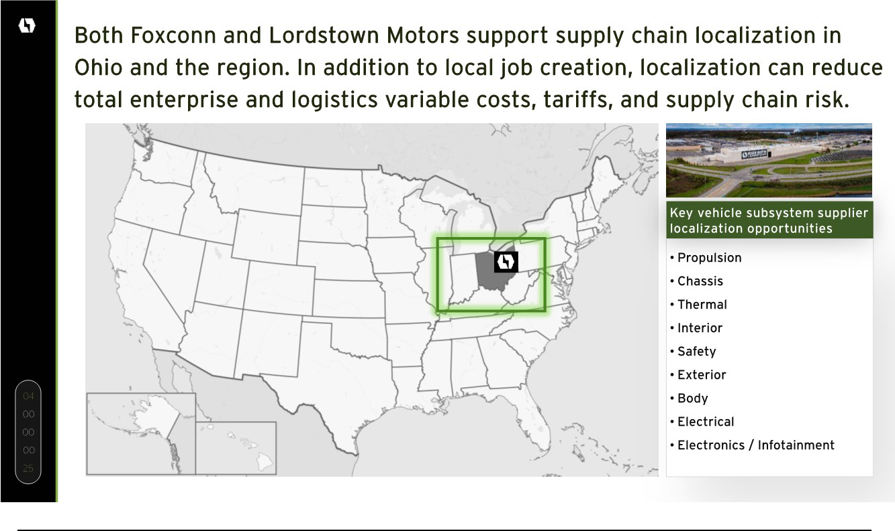

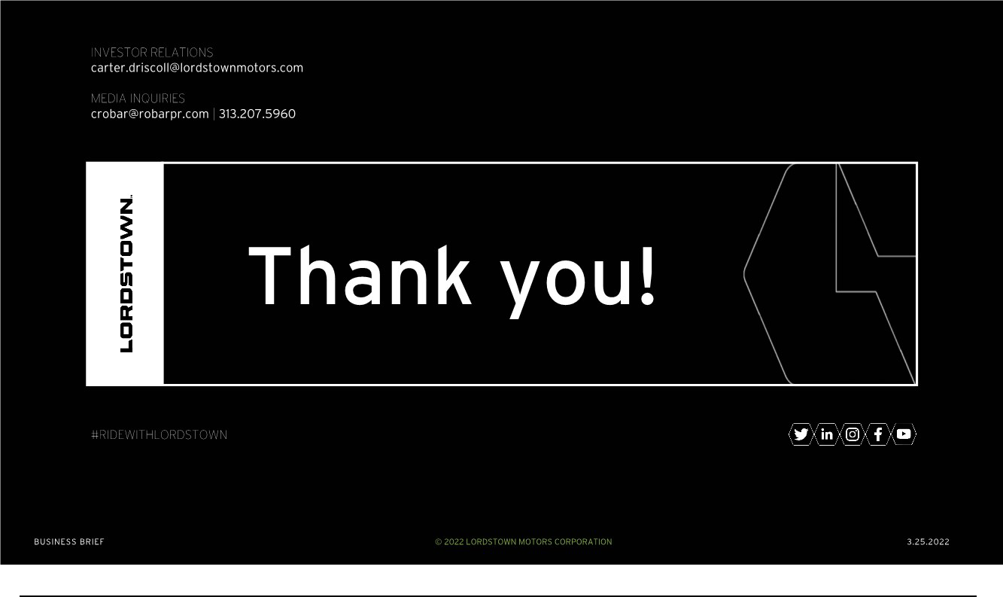

Exhibit 99.4


